Data Analysis

Once we transformed our data set into a time series, we evaluated the characteristics of the Swiss Stock Market Index (SSMI) series from 01/01/2000 to 31/12/2020. We focus our data analysis using the main tests for evaluating the stylized facts.

Autocorrelograms

We started by evaluating the autocorrelation function (ACF). The ACF is a function where daily returns depend on past returns observations. In this test, we want to see whether previous observations are correlated with today’s observation, and we test for each individual correlation coefficient. So, our null hypothesis is that there is no correlation with past returns $(ρ=0)$, coefficients accompanying lagged returns are equal to zero. But, if we reject H0, is because the lagged return is statistically significant and different to zero. Meaning that, the lagged return is significant to explain daily returns and we should take it into account in our autoregressive model.

By looking at the autocorrelogram, all those lags that exceed the nullity band mean that, according to our sample, there is evidence suggesting the autocorrelation is significant. We found no significant lags for today’s returns as every test statistic fell inside the nullity band. This result suggest that the series can be associated with a white noise process because if there are no significant past observations, daily returns only depend on the error term (characteristic of a white noise process).

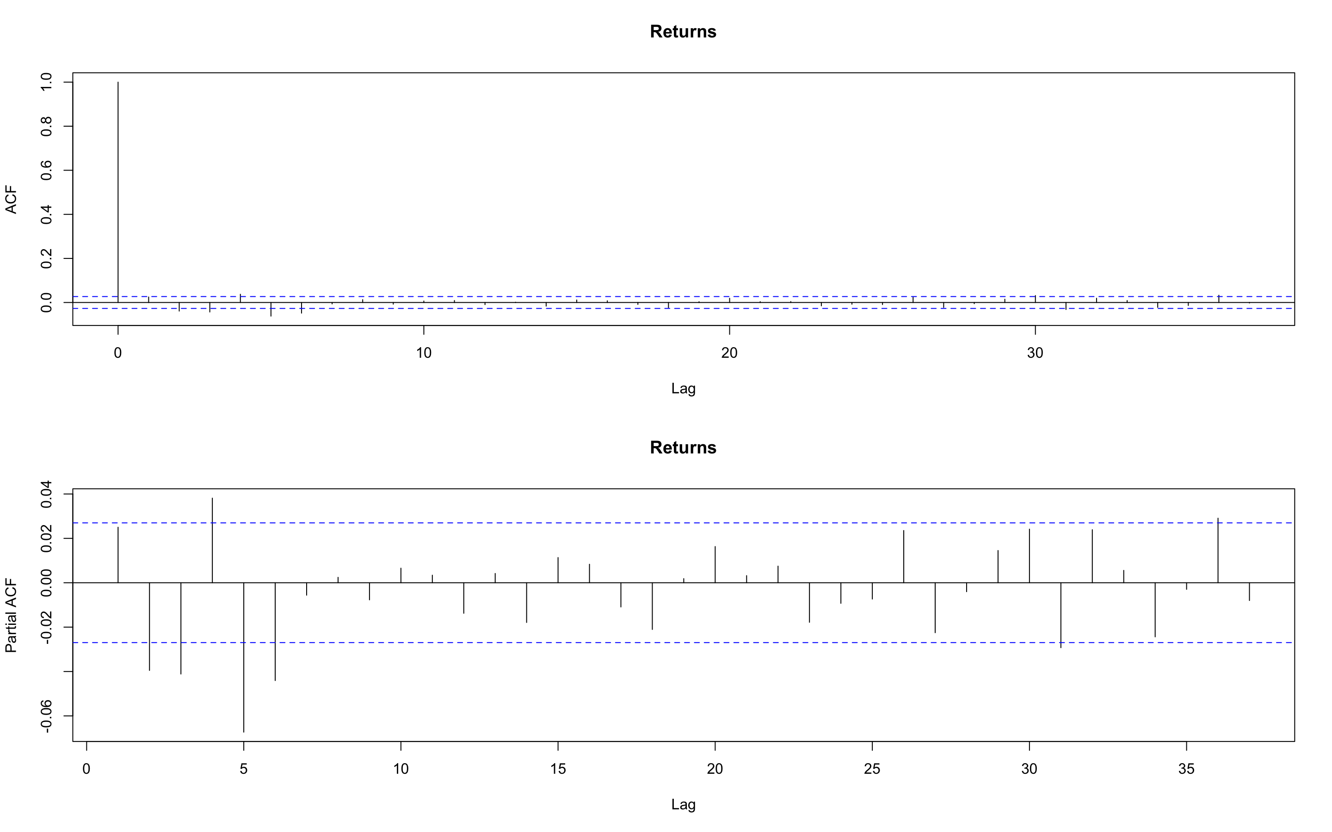

Later, we tested the partial autocorrelation function. In this test we see if the direct effect/influence of the lag return respect to daily returns, eliminating the infuence it contains from other lags (we do not consider the dependency created by the lags between them).

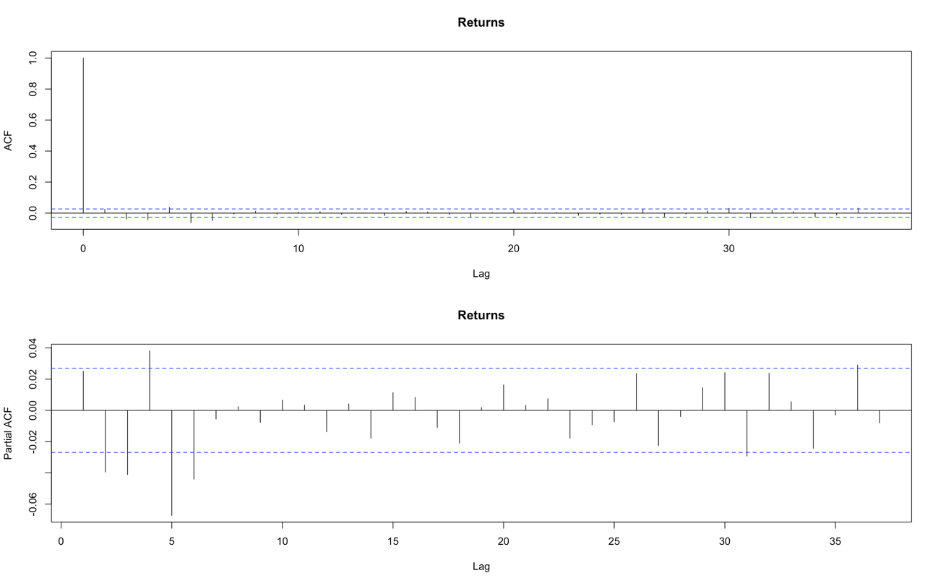

Once again, the obtained results suggest there is no dependency between daily returns and past returns. In consequence, we could assume that the expected value of daily returns is equal to zero.

However, results varied a lot when we transformed the time series into squared and absolute returns.

Dependency of daily returns with recent past observations seemed to be significantly different from zero, and then started falling into the nullity band. We can interpret that shocks are not permanent, they are absorbed through time, and that they should not be associated with a white noise process as there are relevant lags. The effect of lagged variables losses relevance.

These results are important because let us use the squared returns as a proxy of conditional variance, due to the fact that daily returns could be thought as a zero mean process and squared returns cannot.

Normality test

Furthermore, we evaluated if the daily returns series could be considered to follow a normal distribution. This null hypothesis was tested with the Jarque-Bera test.

Firstly, we needed to calculate the kurtosis and the skewness of the series. The kurtosis measures the heaviness of the tails of the distribution. According to our sample, the series had a kurtosis equal to 7.64, much larger than 3 (value for a normal distribution), being a case of leptokurtic distribution. The interpretation of the fat tails result is that there is a higher probability of observing large returns and losses.

The estimated skewness took a negative value of -0.261, which means that number of observations for negative daily returns are greater than the number of positive returns.

These values led us to reject the null hypothesis, the evidence suggests the daily returns do not follow a normal distribution as we can inferred from the histogram below.

It would be wrong to consider daily returns series to follow a normal distribution because we found asymmetry and heavy tails.

White Noise tests

To evaluate if the series could be associated with a white noise process, we used the Box-Pierce test and the Ljung-Box test. For both, the null hypothesis is that there is no correlation between the dependent variable and the past observations of it. In this case, it is a global test, meaning that rejecting the null hypothesis suggest there is at least one relevant lag, not specifying which one. These tests were done for the daily returns and the squared returns. In both cases we rejected the null hypothesis using five lags, which is inconsistent with our findings of the autocorrelograms analysis. However, as we increased lags, the p-value associated with daily returns also increased while it was constant for the squared value case. This means that squared return results are more robust than those obtained for the daily returns.

Stationarity Test

Finally, regarding the tests that could be done for checking the stylized facts of daily returns time series, we ran the Augmented Dickey Fuller Test. This test evaluates the existence of unit roots that implies that the process is no stationary because the influenced of lagged variables is not absorbed over time, shocks are permanent and cumulative, generating deterministic tendency. The results we obtained indicate that the process is stationary as the evidence suggests there is no presence of unit roots. Given the p-value=0.01, we reject the null hypothesis of the existence of unit roots.

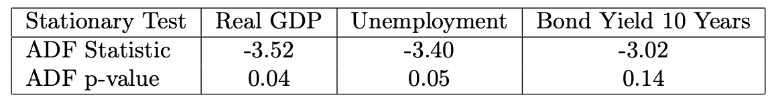

In the table below we can see the main results of the tests we ran for the evaluation of the series stylized facts:

